MODULE - 1
- Explain the steps involved in Fundamentals of Algorithmic Problem Solving.
- Describe the systematic approach for the analysis framework with an neat diagram.
- Write a Sequential algorithm and apply to sort the elements S, A, H, Y, A, D, R, I in alphabetical order and find Best, Average and Worst case of it.
- Explain the General plan for Mathematical analysis recursive algorithms with examples.
- Explain the General plan for Mathematical analysis Non-recursive algorithms with examples.
- Write Quicksort Algorithm and apply to sort the list E, X, A, M, P, L, E in alphabetical order.
- Apply insertion sort algorithm for the given data 90, 89, 68, 45, 34, 29, 17. Find its best-case, worst-case and average-case time complexities.
- Make use of Merge sort algorithm to sort the given data 32, 14, 15, 27, 31, 7, 23, 26. Find it’s time complexity.
- Illustrate DFS based algorithm and source removal method to find the topological sequence for the following graph.
- Write Quicksort Algorithm and apply to sort the list A, L, G, O, R, I, T, H, M, S in alphabetical order.
- Apply insertion sort algorithm for the given data 50, 23, 9, 18, 61, 32. Find its best-case, worst-case and average-case time complexities.
- Apply Merge sort algorithm for the given data 7,6,10,15,21,1,4,19. Find it’s time complexity.
- Solve DFS based algorithm and source removal method to find the topological sequence for the following graph.
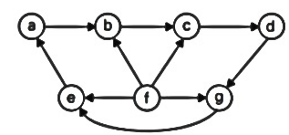
- Apply selection sort algorithm to sort any list (Assume). Find its best-case, worst-case and average-case time complexities.
- Briefly explain Exhaustive Search (Travelling Salesman problem and Knapsack Problem) with suitable examples.

MODULE – 3
- Apply Warshall’s algorithm to find the transitive closure for the given graph.
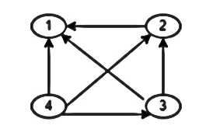
- Determine the minimum cost path from source (S) to sink(T) for the graph using forward approach.
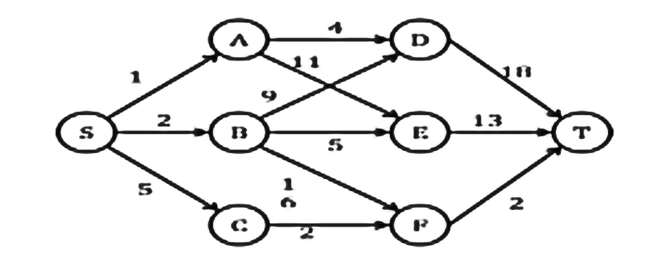
- Apply dynamic programming approach to solve the given Travelling Salesman problem shown
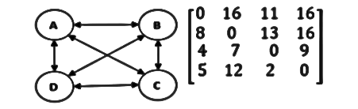
- Implement Floyd's algorithm to find all pair shortest path for the graph given below.
- Apply Warshall’s algorithm to find the transitive closure for the given graph.
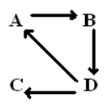
- Determine the minimum cost path from source (S) to sink(T) for the graph Fig. 2(b) using forward approach.
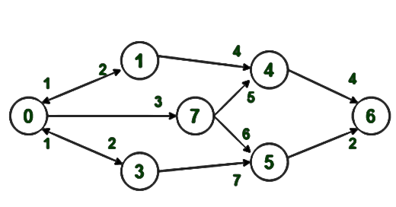

- Make use of dynamic programming approach to solve the given Travelling Salesman problem shown in the graph.
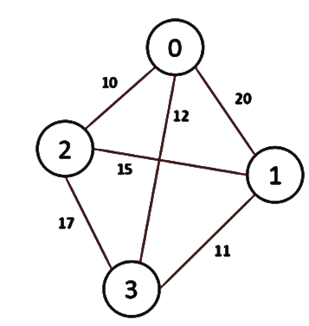
- Demonstrate the Floyd's algorithm to find all pair shortest path for the graph.
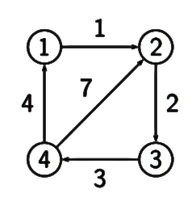
*Note: Link for Travelling Salesman problem using Dynamic Programming approach.
https://www.youtube.com/watch?v=Q4zHb-Swzro

